**Frequency Domain**

**Modeling**

**Lab: 08**



Fall 2022

CSE-3L Control Systems

Submitted by: **Amir Suliman**

Registration No: **19PWCSE1805**

Class Section: **B**

“On my honor, as a student of the University of Engineering and Technology, I have neither given nor received unauthorized assistance on this academic work.”

Student Signature: ______________

Submitted to:

**Dr: Muniba Ashfaq**

December 27, 2022

Department of Computer Systems Engineering

University of Engineering and Technology, Peshawar

**Objectives:**

* To Know about residue.
* To know about inverse laplace transform.
* To know about matlab tool box.

**Task 01:**

find residues of the following

F(s) = 2/(s+1)*(s+2)^2

**Code:**

clc

clear all

close all

num = 2;

denum = [1,5,8,4];

[R,P,K] = residue(num,denum)

**Output:**

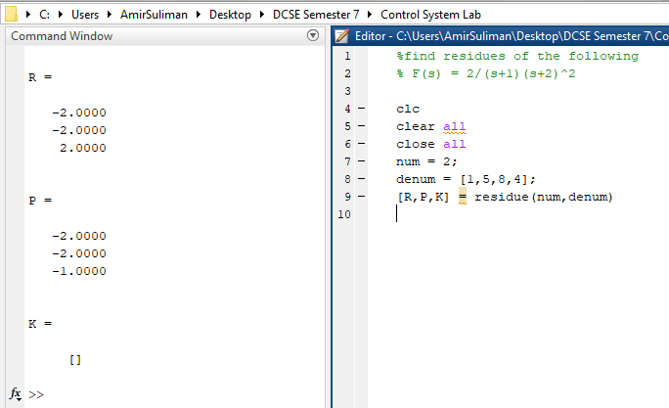

**Task 02:**

Find residues of the following

F(s) = 2/s(s+1)(s+2)

**Code:**

clc

clear all

close all

num = 3;

denum = [1,2,5,0];

[R,P,K] = residue(num,denum)

**Output:**

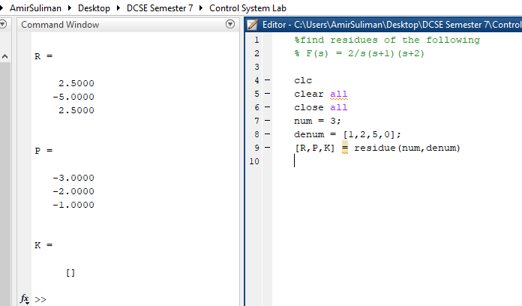

**Task 03:**

find residues of the following

F(s) = 5/(s+1)*(s+2)(s+3)

**Code:**

clc

clear all

close all

num = 5;

denum = [1,6,11,6];

[R,P,K] = residue(num,denum)

**Output:**

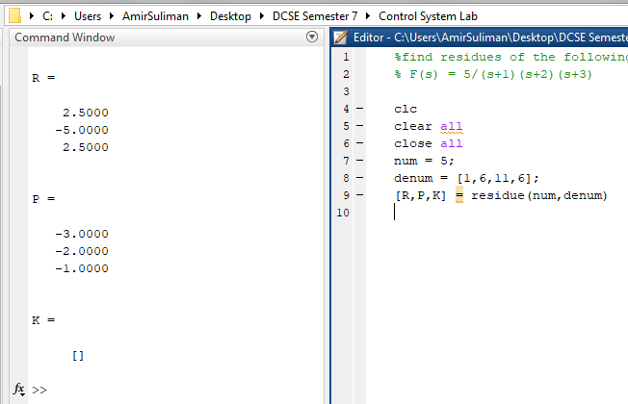

**Task 04:**

% find inverse laplace transform

% of the following symbolic toolbox

% F(s) = 1/s(s+1)

**Code:**

clc

clear all

close all

syms s

c = 1/(s*(s+2));

c = ilaplace(c)

pretty(c)

**output:**

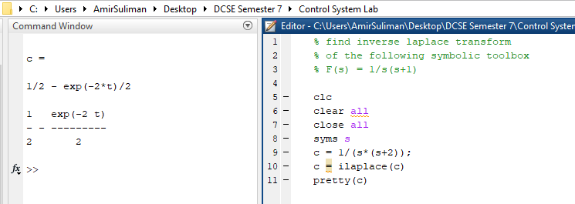

**Task 05:**

% find inverse laplace transform

% of the following symbolic toolbox

% F(s) = 2/(s+1)(s+2)^2

**Code:**

clc

clear all

close all

syms s

c = 2/((s+1)*(s+2)^2);

c = ilaplace(c)

pretty(c)

**OutPut:**

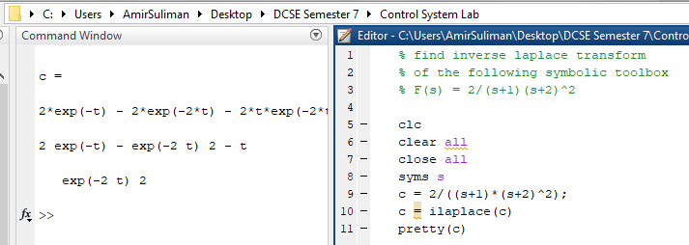

**Task 06:**

% find inverse laplace transform

% of the following symbolic toolbox

% F(s) = 2/s(s+1)(s+2)

**Code:**

clc

clear all

close all

syms s

c = 3/(s*(s^2+2*s+5));

c = ilaplace(c)

pretty(c)

**output:**

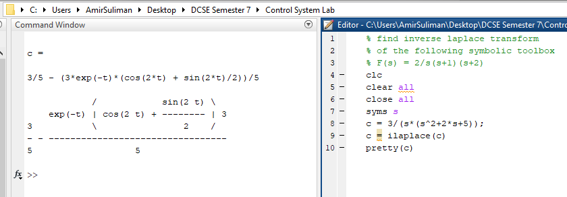

**Task 07:**

% find inverse laplace transform

% of the following symbolic toolbox

% F(s) = 5/(s+1)(s+2)(s+3)

**Code:**

clc

clear all

close all

syms s

c = 5/((s+1)*(s+2)*(s+3));

c = ilaplace(c)

pretty(c)

**Output:**

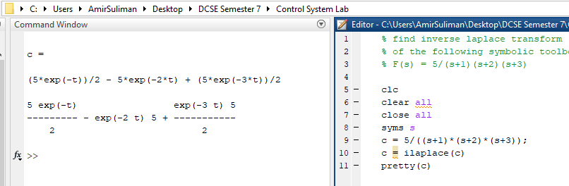

**Task 08:**

% use matlab and symbolic tool box to help you find the values of carsents

% V(s) = (2*s + 2)*I1(s) - (2*s + 1)*I2(s) -I3(s)

% -1*(2*s + 2)*I1(s) + (9*s + 1)*I2(s) -4*s*I3(s)= 0

% -1*(2*s + 2)*I1(s) + (9*s + 1)*I2(s) -4*s*I3(s)= 0

**Code:**

clc

clear all

close all

syms s

syms I1

syms I2

syms I3 V

A = [(2*s + 2), - (2*s + 1), -1;

-1*(2*s + 2),(9*s + 1),-4*s;

-1,-4*s,(4*s+1+1/s)

];

B = [I1;I2;I3];

C = [V;0;0]

B = inv (A)*(C)

pretty(B)

**output:**

